COMPUTER PROJECT #2.

The midpoint between the hard and the easy: “The Friendly Bull Cafecito”

|  |
| --- |
| Induron Paints Used to Rehabilitate Penn State Water Tanks | High ...Water tower in Kill Devil Hills, NC |

**Figure. Water Towers in the US—wish to have several of them in San Juan, PR or across the Island.**

**Featured snippet from the web:**

**“Puerto Rico's governor on Monday (June 29,2020) declared a state of emergency as a worsening drought creeps across the U.S. territory amid the coronavirus crisis. Starting July 2, nearly 140,000 clients, including some in the capital of San Juan, will be without water for 24 hours every other day as part of strict rationing measures.” When you become governor of the Island of Puerto Rico or an engineer, can you help solve the water crisis? In some areas of the world the train company sells “old” 40,000 gal iron pipe wagons, 2.5 inches thick, for $50 US. This pipe wagons are “intelligently” vertically sited to storage water and solve large areas with up to 20,000 inhabitants.**

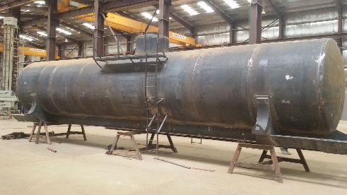

**P#1. Spherical Tank Design. Prepare to solve the water shortage.**

|  |  |
| --- | --- |
| You are designing a spherical tank to hold water for a small village in a developing country (as San Juan, Puerto Rico). The volume of liquid it can hold can be computed as $$V=\frac{πh^{2}\left(3R-h\right)}{3}$$ The cubic equation above can be solved using a numerical method. Not easy to solve it otherwise. If R = 3 m, what depth (h) must the tank be filled to so that it holds V=30 m3? Use the Bisection method to determine your answer. Determine the approximate relative error after each iteration. An initial guess of h is required to initiate the method. Instructor discussed the Bisection method in a separate video. |  |

**Bisection Method**

The following is an introduction to the Bisection Method:

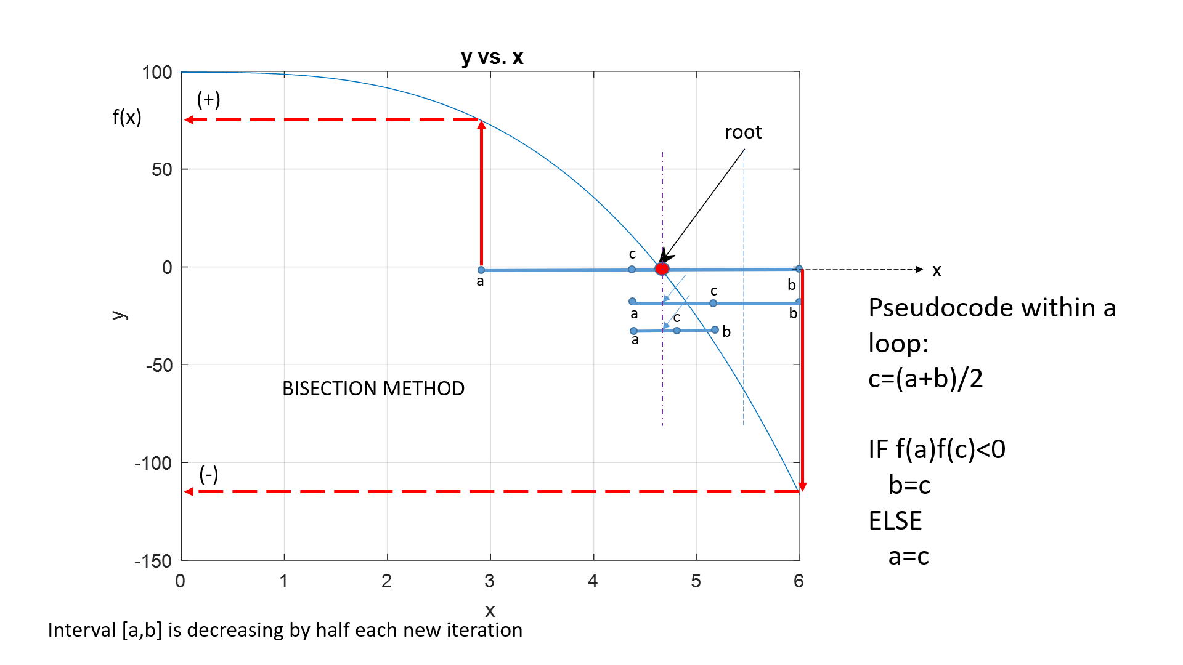

The Figure above shows a few steps of the bisection method applied over the starting range [a,b]. The red dot is the root of the function.

We will say that a root is bracketed in the interval [a, b] if f(a) and f(b) have opposite signs. If the function is continuous, then at least one root must lie in that interval (the intermediate value theorem). See figure above. If the function is discontinuous, but bounded, then instead of a root there might be a step discontinuity which crosses zero (see Figure below). So be careful when you plot a function, not to encounter a discontinuity instead of a root.

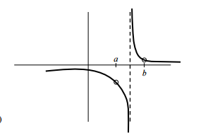

The bisection method is a root-finding method that repeatedly bisects an interval and then selects out of two subintervals in which one the root must lie for further processing. It is a very simple and robust method, but it is also relatively slow (in the standard of our modern and fast computers, this doesn’t matter). The method is also called with other several names: the interval halving method, the binary search method, or the dichotomy method.

The method is applicable when we wish to solve the equation f(x) = 0 for the real variable x, where f is a continuous function defined on an interval [a, b] and f(a) and f(b) have opposite signs. In this case a and b are said to bracket a root since, by the intermediate value theorem, the f must have at least one root in the interval (a, b).

At each step the method divides the interval in two by computing the midpoint c = (a+b) / 2 and the value of the function f(c) at that point. Unless c is itself a root (which is very unlikely, but possible) there are now two possibilities: either f(a) and f(c) have opposite signs and a and c bracket a root, or f(c) and f(b) have opposite signs and c and b bracket a root. The method selects the subinterval that brackets the root as a new interval to be used in the next step, which is half the previous one. In this way the interval that contains a zero of f(x) is reduced in length by 50% at each step. The process is continued until the interval is sufficiently small.

Explicitly, if f(a) and f(c) are opposite signs, then the method sets c as the new value for b, and if f(b) and f(c) are opposite signs then the method sets c as the new a. If f(c)=0 then c may be taken as the solution and the process stops. In both cases, the new f(a) and f(b) have opposite signs, so the method is applicable to this smaller interval.

**Stop Criteria**

For the Bisection Method we can use one or more of the following criteria to stop the iteration process:

1. Interval small enough, i.e., |(b-a)| ≤ ϵ, where ϵ is a very small number
2. |f(c)| very small ,i.e. , |f(c)|≤ ϵ
3. Max number of iterations reached (e.g., iterations<=500)
4. Any number or combination of the criteria listed in (2), (3), and (4). Not easy to understand how to combine criteria in a loop but worth trying.

**Example:** Finding the root of a polynomial, Example (this example is not the function you are going to work for)

Suppose that the bisection method is used to find a root of the polynomial $0=x^{3}-x-2$. The first step is transforming the function to $f\left(x\right)=x^{3}-x-2$ and graph it as f(x) vs x:



Then zoom one of the portions with a root:

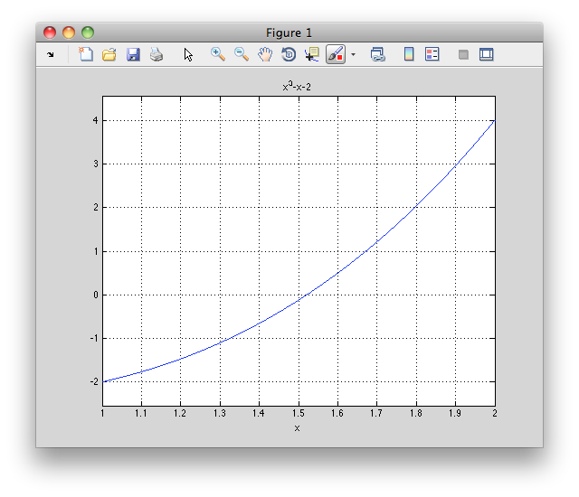

root

Second, two numbers *a* and *b* have to be found such that *f*(*a*) and *f*(*b*) have opposite signs. For the above function, *a=1* and *b=2* satisfy this criterion, as



and



Because the function is continuous, there must be a root within the interval [1, 2]. In the first iteration, the end points of the interval which brackets the root are *a=1* and *b=2*, so the midpoint is

$$c=\frac{2+1}{2}=1.5$$

The function value at the midpoint is $f\left(c\right)={\left(1.5\right)}^{3}-1.5-2=-0.125$. Because $f\left(c\right)$ is negative, and f(a)f(b)>0 the initial *a=1* is replaced with the new *a=1.5* for the next iteration to ensure that $f(a)$ and $f(b)$ have opposite signs.

As this continues, the interval between *a* and *b* will become increasingly smaller, converging on the root of the function. See this happen in the table below (Excel worksheet):

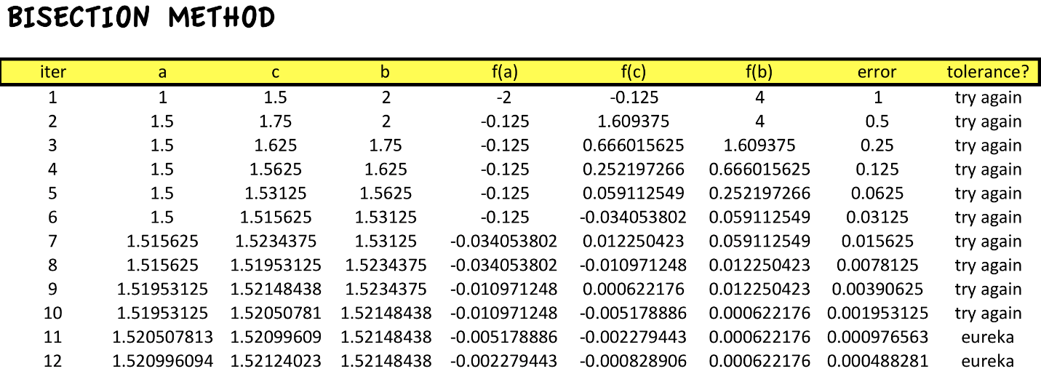

For the above table the root is found for an error tolerance smaller or equal to 1x10-3  (i.e., tol=0.001) The error is defined as error = | b – a |. The process stopped when the error<=tolerance. At the end of the process, the closest value to the root could be a, b or c. The closest to the root is the one x value which gives the closest of f(a), f(b), or f(c) to zero. For the current example the root is the last value of b in iteration 11.

Specifications:

1. Error tolerance, ϵ , 1x10-3

Submit a report in word format

Part-1:

* 1. Simplification of the original equation expressed as f(x)=0
  2. Algorithm in Pseudocode. Be sure you understand how to start the method and how to continue the iteration (take your rusted calculator if needed)

Part-2:

* 1. Python graph (use the plot function, consult L#14). The graph must be done in an independent program (code1). Do not write the code of the graph and the code of the bisection method (code2)in the same program.

Part-3:

1. Well-documented python code (bisection method; code2). Use one criterion to stop the loop. Locate the root and select the two starting points a and b, e.g. a=1 and b=2 in the example above
2. Program output in a table format
3. An output line explicitly identifying the closest root

Part-4:

1. Using the graph showing all roots, construct a list containing a and b values for each root, such as, $L=[a_{1},b_{1},a_{2},b_{2},a_{3},b_{3}]$. Subscripts refer to each root bracketing points. Modified your code2 to produce code3 to find all three roots by referencing to the right pair $[a_{i},b_{i}]$ in each search. This new code **only output** is the three roots, the table on **Part-3.b** is not needed (nor requested)—then code is shrunk. Answer the following question: How do you know which is the real (physical meaning) root (out of three) to solve this problem?.

**Part-5**:

a. We want to construct a plot of h (height of water) vs V (volume of water). Explain how you can do that.

Use abundantly your computer tools and skills to get a short-but-clear quality report—don’t turn in pages and pages of useless information. Essential but complete information is requested—do not duplicate information. NOTE: I **don’t like** black background in code or else.

REFERENCES

1.- Numerical Recipes in Fortran 77. The Art of Scientific Computing, Second Edition. By William H Press, et

2. Video: <https://www.youtube.com/watch?v=DGmNbs5Cywo> ( )

3. Video: <https://www.youtube.com/watch?v=wordn57_Br8> ( )

4. Video: <https://www.youtube.com/watch?v=OzFuihxtbtA> ( )

OJO: Juntas todos los videos y te hacen 12 estrellas de rating (un montón de aprobación), pero no encontré ninguno que hiciera el tema “suficientemente fácil y corto”

Be prepare:

1. What if your professor gives you a different function? $x^{3}=0$, $xlog\left(x\right)=5$, etc. Can you adapt it to your code solution?
2. How do you find the range in x and y coordinates in a graph where roots are located? You need to plot from where [xmin,xmax] and [ymin,ymax]
3. How the interval of root search [a,b] is reduced after each iteration?
4. Why this method uses “iteration” to find the root? Can we just use a formula and find the root?
5. Why this method is called bisection?
6. Is the value of c (the intermediate point) always approaching to the root in each iteration?
7. Can you make 3 iterations of the method by hand (Excel is OK)?
8. What if your professor gives you an interval and ask you if the roots lays on the left or the right of middle point?